**Introduction to basic GIS concepts – Instruction sheet**

--Afghanistan Demo--

**Setting up the environment in ArcGIS**

1. Create a folder on your Desktop named OnSSET_model
2. Open ArcGIS and create a new map
3. Right click to layers → Properties → Coordinate system → Geographic Coordinate Systems → World → WGS 1984
4. Go to Catalog → Connect to folder
5. Insert one by one the layers required for the analysis

**Data Acquisition**

**Polygons**

1. GADM is a comprehensive dataset providing administrative boundary layers for all countries in various formats. Access the website using the following link and download the administrative boundaries layers (level 0 and level 1) for Afghanistan. Source: <http://www.gadm.org/country>
2. Place the downloaded file in the OnSSET_model folder.
3. Insert the administrative boundaries as layers into your open map in ArcGIS. You can do that by simply dragging the files with the shapefile extension (.shp) into your map.

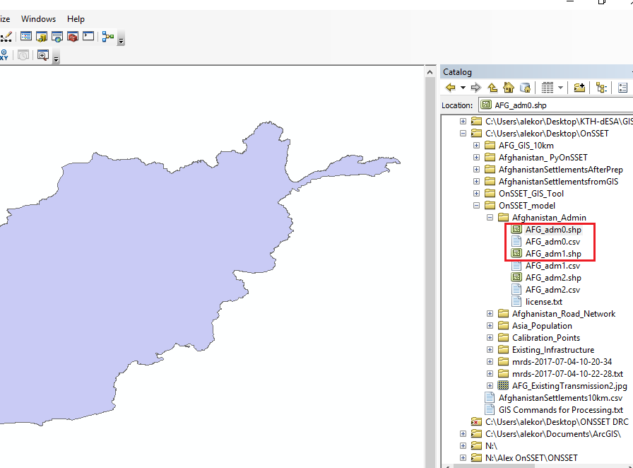

1. Convert the feature layer into a raster using the features to raster functions. You can find the function by simply typing its name in the search window.
2. The new raster layer will be automatically saved in your Default geodatabase with a suggested name. You can change the name to your preference in the output raster cell, that you see within the function.

**Lines**

1. Energydata.info is an initiative of the World Bank aiming to serve as an online repository of energy related geospatial data. KTH dESA has actively contributing to this initiative by providing a number of GIS related datasets. Access the website and use the search box to identify data related to Afghanistan. Download the road network and place it in the OnSSET_model forder.
2. Insert the Road network dataset as a new layer into your map.
3. Open the attribute table by right clicking on the road network layer in the table of contents, which is located on the left part of your screen.

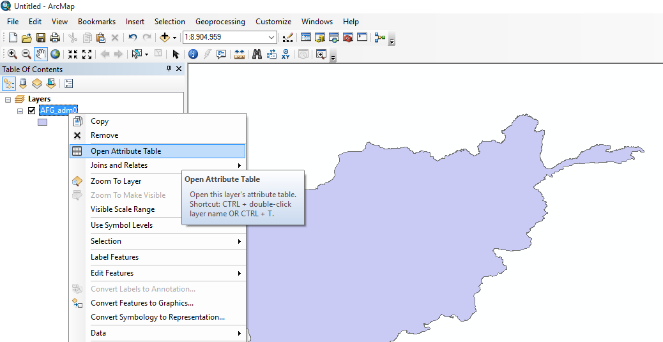

1. Use the function select by attribute in order to identify what is the type of roads that this dataset contains for Afghanistan.

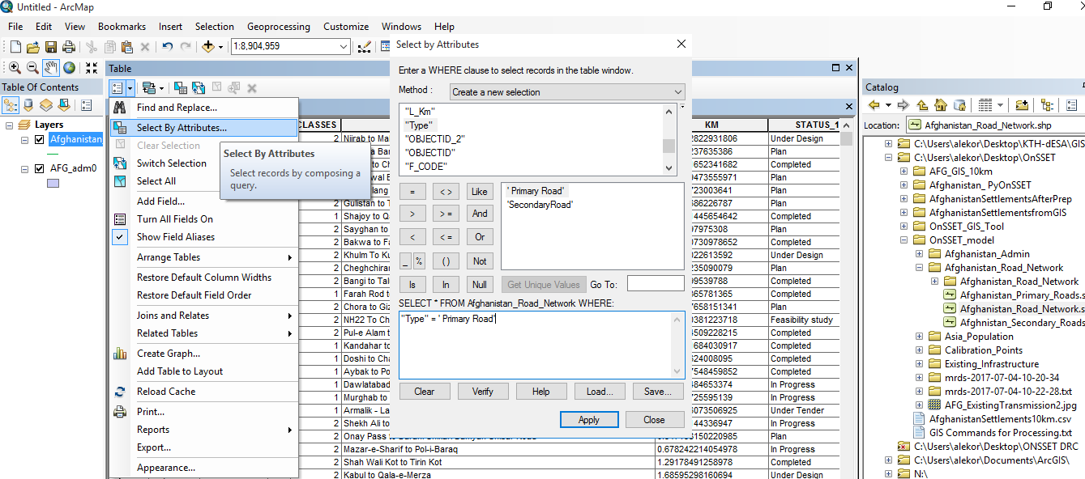

1. Use the selection in order to create two separate layers based on the variable “Type” representing Primary and Secondary roads in Afghanistan.

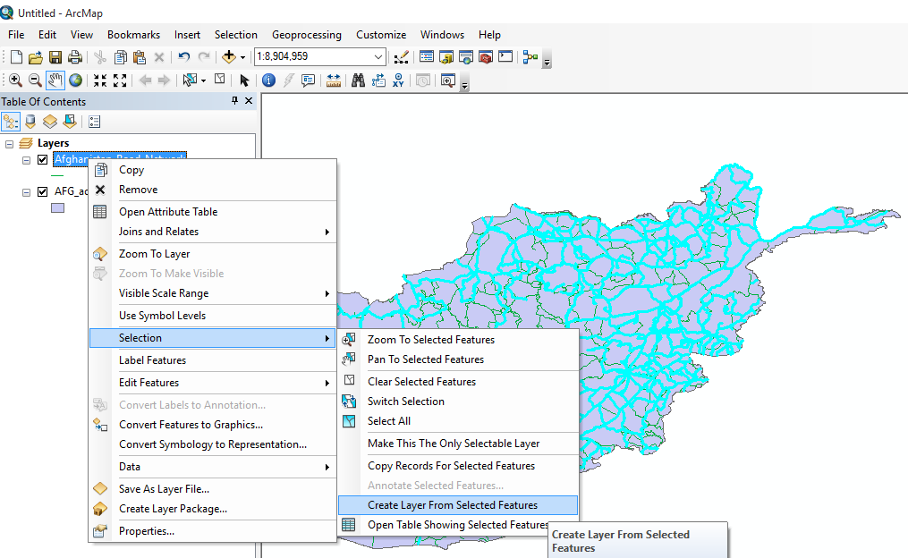

1. Project the feature layer (road network) using the project (data management) function. You can find the function by simply typing its name in the search window. Please use WGS 1984 World Mercator projected coordinate system.

**Points**

1. Download the world mineral resources dataset from <https://mrdata.usgs.gov/general/global.html> (the USGS website) as csv file.
2. Place the downladed file into your OnSSET_model folder.
3. Insert the dataset into your map as a layer using the Add XY data function and by selecting X as longitude and Y as latitude. Define the coordinate system as WGS 1984.

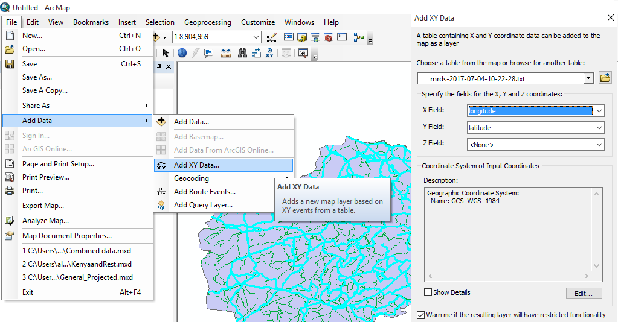

1. Use the clip (analysis) function in order to select and keep only the point data that lay within the Afghan borders. You can find the function by simply typing its name in the search window.
2. Export the “events” layer as shapefile in the OnSSET_model folder.

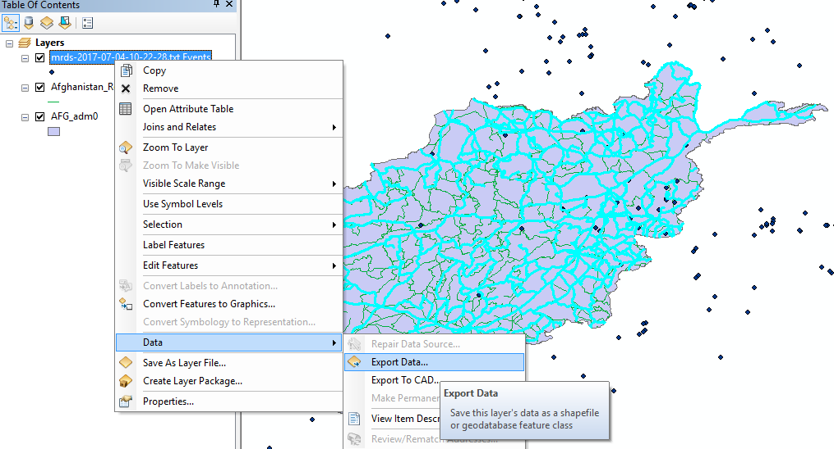

**Raster**

1. The population dataset is the basis of the OnSSET analysis. Population datasets are available both in raster and vector formats. Its resolution defines later on the resolution of the OnSSET analysis. In this example we will work with a raster dataset provided in 1 km spatial resolution. Please, access <http://www.worldpop.org.uk/> and download the regional population dataset for Asia.
2. Insert the dataset into the map as layer.
3. Clip the population dataset using the administrative boundaries of Afghanistan so as to reduce the volume of the dataset and to lower the processing time of the electrification analysis on the following stages. **Note!** The clipping function for raster layers is called Extract by mask.
4. Project the raster population for Afghanistan using the project raster (data management) function. You can find the function by simply typing its name in the search window. Please use WGS 1984 World Mercator projected coordinate system.

Data creation and manipulation

**Digitization process**

1. Create a new GIS file by going to File → New → Blank map
2. Right click to layers → Properties → Coordinate system → Geographic Coordinate Systems → World → WGS 1984
3. Insert the Administrative boundaries (level 0) for Afghanistan and set the color as No fill (basically no color selected).
4. Go to Catalog → your new folder (e.g. OnSSET_model) → right click → new → shapefile. Provide name as calibration_points, select feature types as point and define the Geographic Coordinate Systems as WGS 1984 (Under the category World).
5. Make sure that the Georeferencing module is active on your ArcGIS. You do that by right clicking on the main upper ribbon, and ticking on the relevant module.
6. Now on editor (upper ribbon), select start editing. Select the points layer and click ok.
7. You should be able to add new points onto the map. Please add 6 new points on the edges of the country’s area equally distributed around the periphery. Save edits and click on stop editing. You should be able to have something like this:

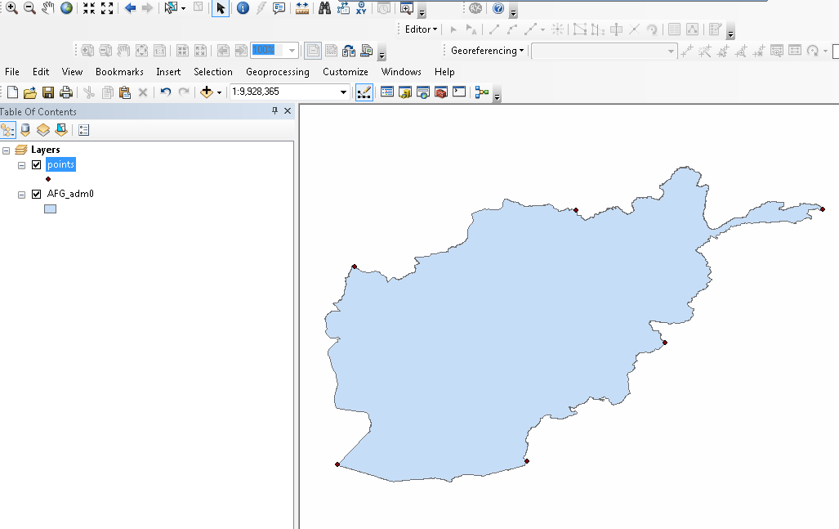

1. From the upper ribbon select add data, and then import the image of the Afghan Transmission network existing in your OnSSET_model folder. On the windows appearing click No and Ok.
2. On the Georeferencing tab (upper ribbon) click fit to display (make sure that the image is selected for this process). Now you should be able to see the following:

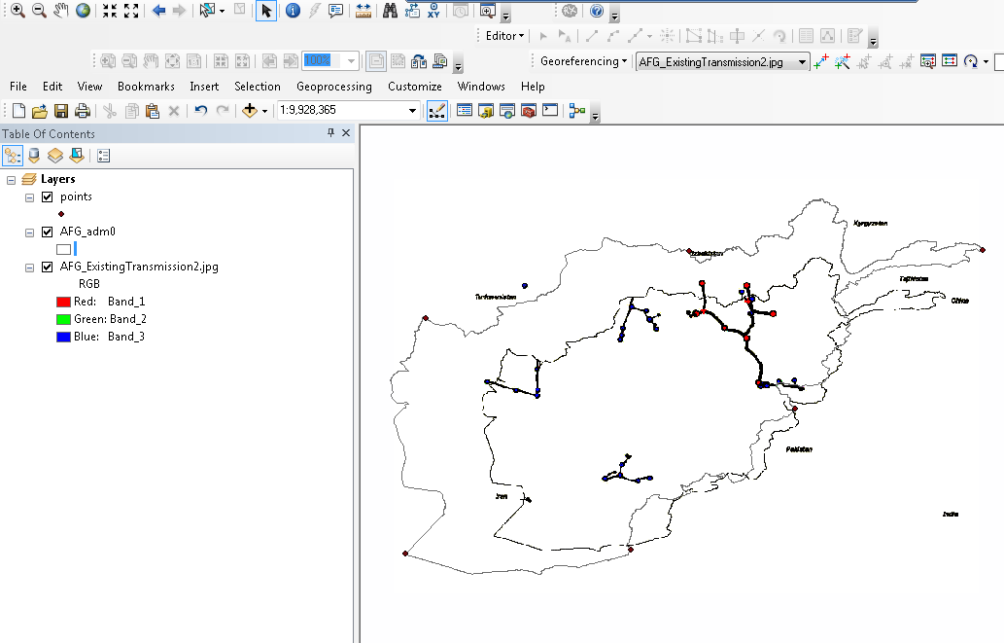

1. On the Georeferencing tab, click Add Control Points and one by one try to match the points on the image map to the calibration points that you have created. The result will look like this:

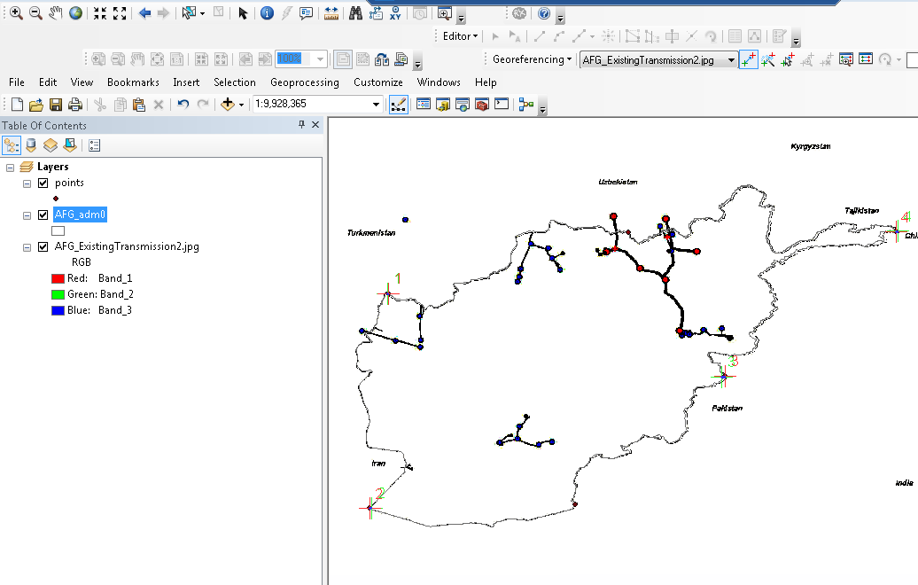

1. You can have a look at the Link table in the Georeferencing taband more specifically on the residuals. The lower the residual the better the fit. Yu can delete the residuals that have high values.
2. Finally, when you feel comfortable with the result, click Rectify and save the layer in the OnSSET_model folder.

**Creating new power infrastructure Layers (power plants – transmission lines)**

1. In the OnSSET_model folder, create a sub-folder called Existing_Infrastructure.
2. Go to Catalog → your new folder (e.g. Existing_Infrastructure) → right click → new → shapefile. Provide name as Current_Power_Plants, select feature types as point and define the Geographic Coordinate Systems as WGS 1984 (Under the category World).
3. Add the Current_Power_Plants layer into your map.
4. In the table of contents, right click on the Current_Power_Plants layer and open attribute table.
5. The table is empty, so we have to provide fields that correspond to the attributes that power plants might have (e.g. type, year of construction, MW, operating status etc.). Please make sure that every variable is defined properly. For example MW should be defined as float while Type as text.
6. Using the digitized map from the previous process insert all the power plants that you see on the map using the editor tab as shown before. Note, that this time you can select particular points and provide attributes to them.
7. Follow a similar process for the transmission lines. Note that in this case the new shapefile should be Polyline instead.
8. Same process shall be followed for the planned infrastructure. After this exercise you should be able to create new vector files or manipulate existing ones.

**Creating and populating a geodatabase**

1. Right click on the AFG_GIS_10km folder and create a new File Geodatabase with the name Afghanistan.
2. Right clicking on Afghanistan.gdb you will be able to import data. You can use multiple import for feature classes and raster datasets should be imported one by one.
3. Once the geodatabase is populated you can start building the file to be used as input to the OnSSET model (or what we call the settlement file). Please use the txt file called “GIS commands for processing” that will guide you through all the GIS processes and the use of python.

**Export the settlements layer into a .csv file**

The settlements layer contains the population points throughout the country’s territory along with 16 attributes that are useful for conducting the electrification analysis with OnSSET. In order to continue with the electrification model, this layer needs to be extracted from GIS to a csv file. Here are two options of how this action can be performed.

1. Use the OnSSET_GIS_Tool which has been developed for this exact reason. The tool can be downloaded from KTH dESA’s github channel.
2. The settlements file is a shapefile. That is, a dbf file is always existing in the same directory. This dbf file contains the trivial information of the settlements file and can be opened via Excel. Then one can use excel to save the file as csv.

